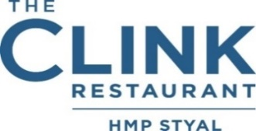

**Mains**

Catch of the day, burnt butter potato puree, wild mushroom, spinach, truffle oil

Pulled beef shin, grilled polenta, tapenade, crispy cavolo nero, rainbow chard

Lentil & bean cassoulet, braised red cabbage, focaccia VE

**Desserts**

Apple & almond pithivier, cinnamon anglaise, honeycomb ice cream VE

Sticky toffee pudding, banana ice cream, caramel sauce